Modeling
We tested the performance of numerous models for gender prediction. We evaluated each model using accuracy and F1-score, for both male and females – as class imbalance was a significant challenge in our dataset.
Our target variable was ‘gender’ (categorical value), we tested the following models on our dataset:
Model | Accuracy | F1-Score (Male) | F1-Score (Female) | Notes
Logistic (raw) | 62% | 0.00 | 0.77 | Biased to Female
Logistic (balanced) | 52% | 0.45 | 0.57 | Better class balance
SMOTE + Logistic | 53% | 0.44 | 0.59 | Slight improvement
Random Forest | 59% | 0.22 | 0.73 | Struggles with Males
XGBoost | 56% | 0.01 | 0.77 | Worst male recall
KNN (k=3) | 55% | 0.36 | 0.65 | Balanced but moderate

As you can see, the Logistic Regression (raw) model was biased towards predicting females. For this reason, we tried the balancing the Logistic Regression. This resulted in the accuracy to drop by 10% to 52%, however, the performance was more balanced, with the F1-score for male increasing to 0.45 and for females decreasing slightly to 0.57. This trade-off shows that that the class weighing helped.
We tried to balance this further by using SMOTE, but this resulted in a very slight improvement of 1%.
The Random Forest model struggles with male predictions but had a decent accuracy of 59%.
XGBoost had a F1- score of just 0.01 for males.
The KNN (4=3) model had a moderately balanced performance for males and females and moderate accuracy of 55%.
Below we used a bar chart to compare just some of the models with
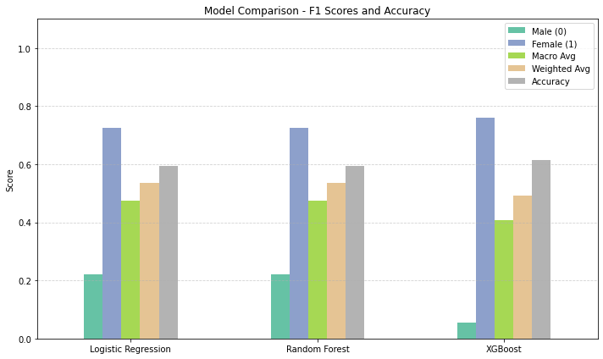
Visuals for Logistic Regression – Balanced
Precision-Recall Curve - Important when one class dominates
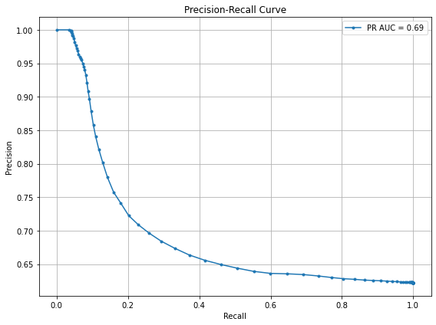
Value counts: Gender
Male 187596
Female 114093
This evaluates how well the model performs, especially when dealing with imbalanced classes.
AP (Average Precision): The area under this curve, AP = 0.69 in this case - the model maintains moderate precision across varying levels of recall.

- This is significantly better than random
- It suggests your model has some predictive power, even if the ROC AUC was low (0.54).
ROC Curve - Especially useful for class imbalance — this shows performance tradeoffs
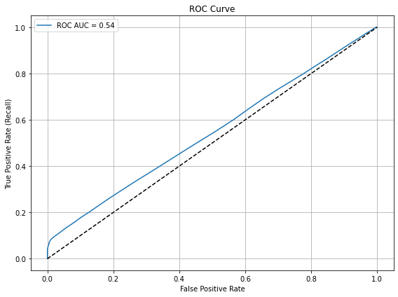
This shows the model's ability to distinguish between classes (e.g., predicting gender).
AUC Score = 0.54
- AUC (Area Under Curve) ranges from 0 to 1:
- 0.5: Random performance.
- 1.0: Perfect classification.
- < 0.6: Very poor performance.
- 0.54: This is only slightly better than random. The model is not effectively distinguishing between the classes.

Confusion Matrix - actual vs. predicted class counts
The model is heavily biased toward predicting “Female (1)”
It correctly identifies most females, but struggles with males — often misclassifying them as female
Out of 22,819 actual males, only 3,485 were correctly predicted → that’s very poor performance for class 0 (Male
The model is much better at identifying Female (1) than Male (0)

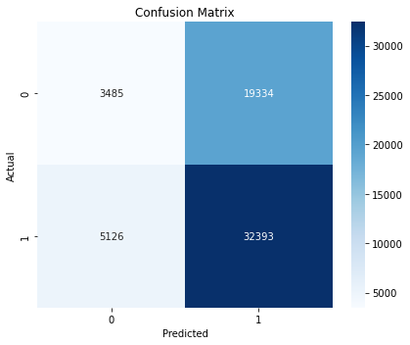

Visuals for Random Forest
Feature Importance Plot - This will show which features are driving the model's predictions
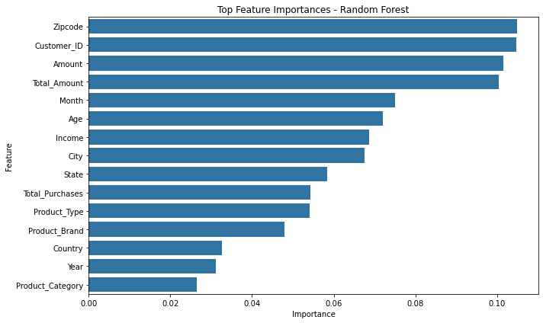
This ranks features based on their importance in the Random Forest model.
Higher values mean the feature contributes more to the model's predictions.

- The most important features are: Zipcode, Customer_ID, Amount, Total_Amount.
- We should consider dropping Customer_ID to see what difference it makes to the model’s ability to predict gender correctly.

ROC Curve - Especially useful for class imbalance — this shows performance tradeoffs
This shows the model's ability to distinguish between classes (e.g., predicting gender).
AUC Score = 0.54
- AUC (Area Under Curve) ranges from 0 to 1:
- 0.5: Random performance.
- 1.0: Perfect classification.
- < 0.6: Very poor performance.
- 0.54: This is only slightly better than random. The model is not effectively distinguishing between the classes.

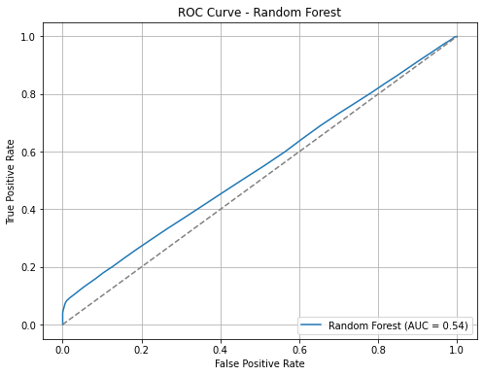

Precision-Recall Curve - Important when one class dominates
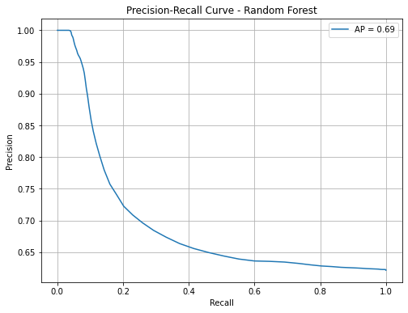
It evaluates how well your model performs, especially when dealing with imbalanced classes.
AP (Average Precision): The area under this curve, AP = 0.69 in this case - the model maintains moderate precision across varying levels of recall.
- This is significantly better than random (which usually gives a low AP, often near the positive class ratio).
- It suggests your model has some predictive power, even if the ROC AUC was low (0.54).

Misclassification Analysis - bar chart of correct vs. incorrect predictions
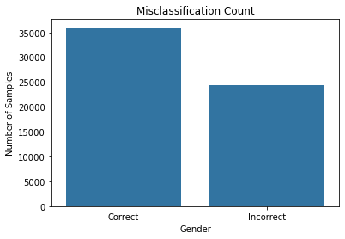
Correct Predictions: Represented by the left bar, with a height around 36,000. This indicates the number of samples where the Random Forest model predicted gender correctly
Incorrect Predictions: Represented by the right bar, with a height around 24,000. This indicates the number of misclassified samples—i.e., where the predicted gender did not match the actual gender
The Random Forest model made more correct predictions than incorrect ones, suggesting it performs reasonably well.

Confusion Matrix - actual vs. predicted class counts – Random Forest
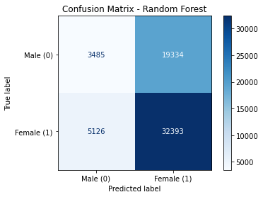
The confusion matrix shows the performance of the Random Forest model on gender classification where:
- 0 = Male
- 1 = Female
True Positives (TP): 32,393 — Female correctly predicted as Female
True Negatives (TN): 3,485 — Male correctly predicted as Male
False Positives (FP): 19,334 — Male incorrectly predicted as Female
False Negatives (FN): 5,126 — Female incorrectly predicted as Male

High accuracy for Females: Recall = 86.3%
Poor performance for Males: Recall = 15.3%

Visuals for KNN k=3
Confusion Matrix - actual vs. predicted class counts – KNN k=3
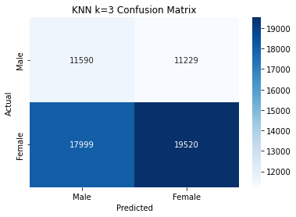
Accuracy: 55%
This means the model predicted the correct gender 55% of the time on the test set.
This shows the model is relatively balanced, but its predictive power is weak for both classes, especially due to the high number of false positives/negatives.

Classification Report – Heatmap
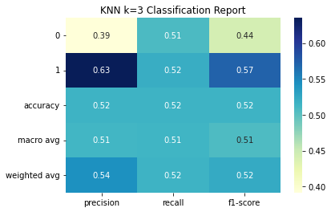
Class 0 = Male
- Precision: 0.39 (many false positives)
- Recall: 0.51 (barely half the actual males are correctly predicted)
- F1-score: 0.44 (low overall performance)
Class 1 = Female
- Precision: 0.63 (relatively better)
- Recall: 0.52
- F1-score: 0.57
- The model is moderately biased towards predicting females.

Tableau
CUSTOMER SPENDING ANALYSIS DASHBOARD
Insights by Gender, Income, Category, and Time
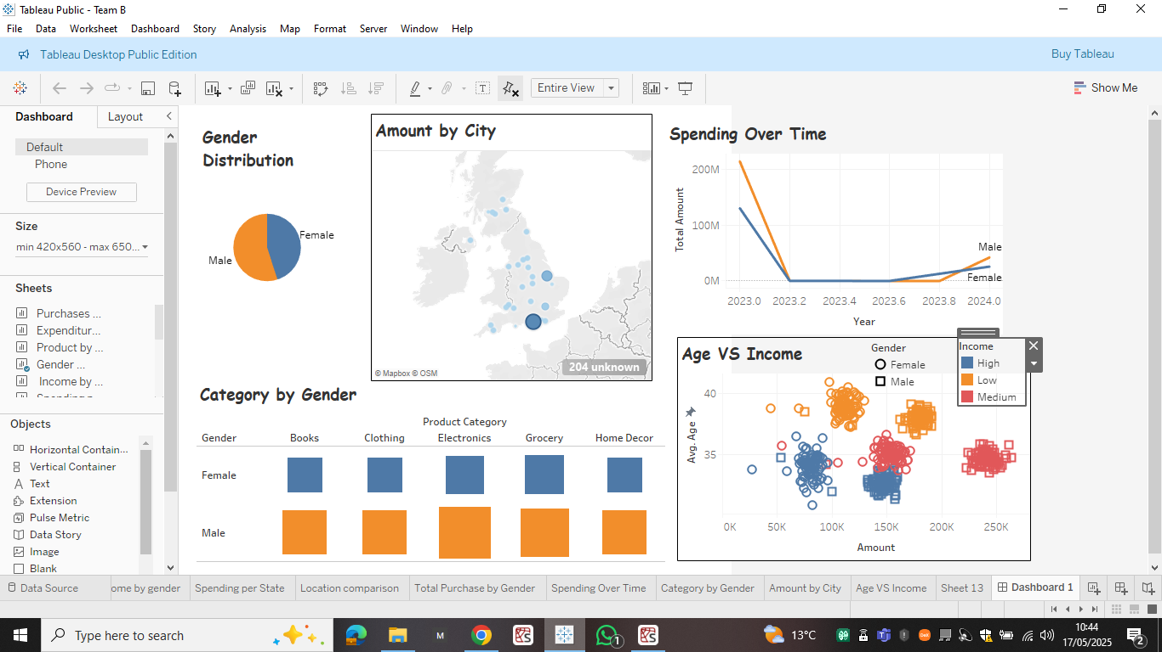

Gender Distribution
Pie chart shows an unequal distribution between Male and Female consumers.
- Balanced representation ensures fair analysis across genders.
- Important for marketing and segmentation strategies.

Spending Over Time
- Timeline from 2023 to 2024.
- Observation:
  - High spending peak in early 2023, followed by a dip and gradual increase into 2024.
  - Males have slightly higher total amounts towards 2024.
- Implications:
Possible seasonal effects or market events.

Amount by City
- Map visualisation shows spending concentration by city.
- Observation:
  - Major cities have higher spending (indicated by larger circles).
  - London and surrounding areas show a dominant share.

- Product category preferences segmented by gender
- Males outnumber females in all the listed product categories, however, if we consider the gender imbalance, then we can assume that there is no significant difference between male and female engagement.

Age vs Income Analysis
- Scatter plot analysis with filters for Gender and Income Levels.
- Key insights:
  - High-income individuals mostly spend around the 150K mark.
  - Younger individuals (30–35 age group) contribute significantly to spending.

Key Takeaways
- Gender preferences vary significantly by product category.
- Spending over time shows a recovery trend in 2024.
- Income and age play vital roles in determining spending behaviour.
- Regional spending insights can support targeted campaigns.

